WALK 6 TURLIN MOOR TO POOLE QUAY
Ordnance survey map: OL15 Grid reference: start SY 980 915 finish SZ 011 903
Transport (check current timetables):
More Bus: 8 and 9 Poole/Hamworthy/Turlin Moor circular.
South West Trains: Poole and Hamworthy stations.
Car Parking: side roads at Turlin Moor, town car parks in Poole.
Approximate distance: 11 km, 7 mls allow 4 hours.
Countryside Code: always follow the Countryside Code. Check online for latest version.
Facilities en route: refreshments and toilets in Upton Park and in Poole.
Nature of route: footpaths, tarmaced paths and roads. No stiles.
Special interest:
Connecting trails: Castleman Trailway at Upton Park.
Connecting harbour walks: Walk 6a - Upton Country Park/Upton Heath/Roman road, Walk 6b - Upton Country House/Cobbs Quay/Hamworthy Park/Lytchett Bay.
Note: a compass would be useful.

(1) From Poole take the number 8 More Bus circular (Poole/Hamworthy/Turlin Moor) to its Foreland Road stop.

Go over the railway footbridge (S) and up to the road that serves the caravan park. Proceed through the gate opposite and onto Ham Common. Follow the track around to the right and to the cliff overlooking Arne, the Wareham Channel and Ham beach.

(2) The track drops down onto the beach at some steps. Turn left along the beach to the car park. Go across the car park onto the beach on the other side.

(3) Take a road between two houses to the left of the beach to join Lake Drive and turn right. Pass the marine base on your right, the road bears left, then turn right into Lake Avenue. After passing a walled complex turn right into Lake Road.

You will pass some old Hamworthy cottages on your left before turning left into Branksea Avenue and following through to come out into Hamworthy Park. (There is easy access to the Harbour along a promenade here.) Cross the park and head for the exit near the public conveniences. (By turning right, you could go along the beach for a few hundred metres instead.)

(4) Leave the park and go over the level crossing (near the car park) and on to the lights at the end of Ashmore Avenue.

Turn right onto Blandford Road and left at the traffic lights into Blandford Close.

The road turns left and before the school entrance turn right onto a track alongside the football pitch up to the top corner of the tennis court. Turn left and follow the track along the back of the courts until you come out onto the water’s edge. (NB: in June 2022, this path is being replaced by the Hinchcliffe Cycleway.) If too muddy or overgrown, bypass by retracing your steps to Blandford Road. Turn right on to Blandford Road, right down Hinchcliffe Road and left along footpath.
(5) Turn left on the bridleway and right down the footpath between the houses and the harbour. Follow this through until you reach the boatyard and turn left up to the road.

Turn right along the road and turn in a while into the boatyard. Take the left hand pathway just before the entrance to the boatyard.

This turns right at the end of the boatyard buildings and leads on to open ground.

(6) Head across the open ground towards the harbour and follow the pathways near to the shore around to the end near the railway embankment.

(7) Turn left at the road between houses then right for a few metres before you go through a metal barrier on your right onto a footpath leading to an archway underneath the railway line.

(8) Turn right at the gate in Upton Country Park and follow the gravel track. Ignore two paths on your right and then take the next right fork, leading to a kissing gate and turn left. Continue over a long boardwalk and follow the footpath alongside the harbour, avoiding left turns..

(9) Continue to the gate and join the pathway that runs alongside Holes Bay.

(10) When you arrive in Poole bear right, keeping Asda on your right to go down West Quay Road on to Poole Quay.

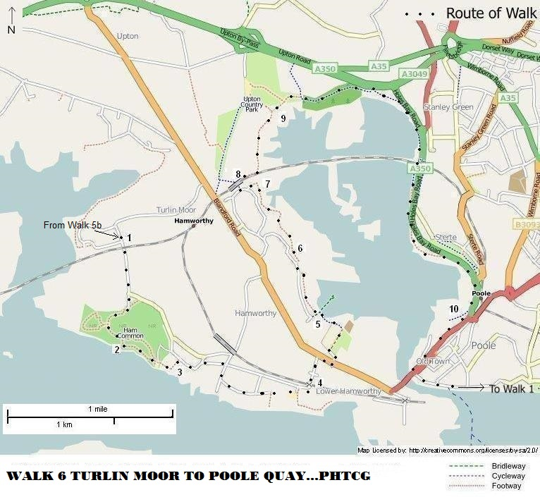
Map reproduced from http://www.openstreetmap.org/index.html

Revised 23/6/22

