WALK 5b: SANDFORD TO TURLIN MOOR

Ordnance survey map: OL15
Grid reference: start SY 931 898 finish SY 980 915
Transport (check current timetables):
Bus: Purbeck Breezer 40 Poole/Swanage, and More Bus 8 and 9 Poole/Turlin Moor circular.
South West Trains: Poole, Bournemouth, Wareham, Hamworthy and Holton Heath railway stations.
Car Parking: side roads in Sandford and Turlin Moor.
Countryside Code: always follow the Countryside Code. Check online for latest version.
Approximate distance: 13.5 km, 8.5 mls, allow 5 hours.
Facilities en route: pubs at A35/A351 roundabout and in Lytchett Minster.
Nature of route: heathland, roads, woodland, urban open space.
Connecting harbour walks: Walk 5a – Sandford via Organford, Walk 6b
Upton Country Park, Ham Common and Lytchett Bay. See our website, http://www.pooleharbourtrails.org.uk
Note: a compass would be useful.

WALK 5b: SANDFORD TO TURLIN MOOR

- Join the route on the A351 opposite the end of Keysworth Drive. Take a small footpath that starts opposite a bus stop and goes through the shrubs in a north-westerly direction leading on to Filleul Road. Follow this road up to the right, and on a left hand bend, where it becomes Miles Avenue, go straight on to the end of Filleul Road (a cul-de-sac). Pass through the gate on your right onto the Great Ovens Heath nature reserve and take the right hand footpath. Follow the path across the heath and boardwalks.
- When you reach a footpath crossing left to right just after a nature reserve notice board, turn right onto the footpath and follow this for 2.5 km until you approach the end of the wooded section.
- As the main path continues around to the left, turn sharp right along the bridleway. Turn left into a lane at the T-junction and go straight out onto a public road.

- Go straight over the bridge and through Organford and then fork right along the road which leads out onto the main Dorchester road, the A35.

- Follow the road to the right using the wide grass verge until you reach the roundabout at the Bakers Arms. Cross the road with care to turn left at the roundabout and head towards the village of Lytchett Minster.
- Continue through the village along Dorchester Road and across the bridge over the dual carriageway. Immediately after the bridge is Policeman’s Lane on your right.

- Go down Policeman’s Lane. Turn right when the road bears left, going into Watery lane, which turns left into Slough lane. At the next junction, Slough Lane continues to the left (NE). (Turn right here to get access to an excellent harbour view, taking the path to the left of the sewage works.)
Alternative via Frenches Farm Fields: (7) Go down Policeman’s Lane. Turn right when the road bears left, going into Watery Lane. Almost immediately, with Osprey Close on your right, turn left into a small car park. Continue through the gate opposite onto a winding gravel path. As the path bends right, come to two left turns in succession. Take the first left and fork left immediately on to a trodden path. As this path starts to bend to the right, go through a gate ahead on to a straight, trodden path. At the end emerge through a gate on to Slough Lane. Turn left.

- At the end of Slough Lane turn right (sharp right down Beach Road gives access to the harbour) and continue along Sandy Lane, passing a nature reserve on your right (which also gives access to the harbour). Turn right into Lytchett Way, cross the next road and keep straight on along the path between the houses, and, after crossing another road, continue along a tarmac path between houses.
- At a T-junction, turn left onto a footpath. (At this point you can use the footpath on your right to get to the harbour.) Pass through a metal barrier and take the right fork onto Border Road. When you come to an information board, turn right onto a footpath towards the Lytchett Bay View. When retracing your steps from the viewpoint, take the grassy path on your right along the hedge line and head into the woods. Before reaching the road, turn right to cross over a bridge leading to a gravel path on to Turlin Moor.
Alternative: Retracing your steps from the view point there is now a bridge on your right you can use as a short cut to the gravel path on Turlin Moor, where you turn right.

- Follow through to the right along the gravel path, keeping the woodland on your right. (You are now on the Poole / Dorset boundary.) Follow this until you come out into a field, turn right along the edge of the field and join the water’s edge of the harbour, bearing left with the path.
- Follow the track around the edge of Lytchett Bay, passing a bird hide on your right. Head for the point where the houses are close to the harbour. Take the path to the right behind the houses, and then pass through a cycle barrier onto a path that runs alongside the water with the houses on your left.

- When you reach the slipway turn left up the steps and take the paved pathway straight ahead between the flats and houses until it joins Egmont Road and continue to the junction with Foreland Road and the start of Walk 6. You can catch a More Bus number 8 or 9 bus to Poole. Hamworthy railway station is nearby.

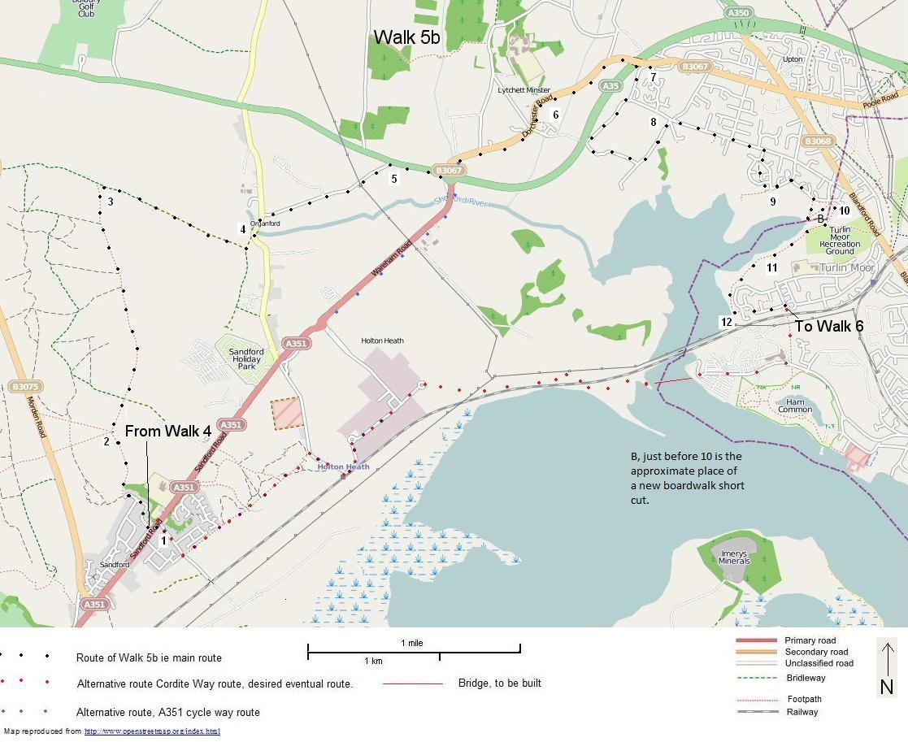

WALK 5b SANDFORD TO TURLIN MOOR…PHTCG

Revised 18/10/21

