WALK 1 POOLE TO GREENLANDS
Ordnance survey map: OL15 Grid reference: start: SZ 011 903 finish: SZ 025 843
Transport (check current timetables):
Bus: Route ONE Poole Circular, More Bus 8, 9 Poole/Turlin Moor circular. Return Purbeck Breezer 50 Swanage/Bournemouth via Sandbanks (from Goathorn Farm bus stop). Change at Westbourne to return to Poole or catch Purbeck Breezer 60 Poole/Sandbanks.
South West Trains: Poole Station.
Car Parking: Poole, Whitecliff, Sandbanks.
Approximate distance: 12 km, 7½ mls, allow 4 hours
Countryside Code: always follow the Countryside Code. Check online for latest version.
Facilities en route: toilets in Poole and Sandbanks and on Whitecliff Recreation Ground; refreshments in Poole and Sandbanks.
Nature of route: Tarmac from Poole to the Ferry, beach and heath from Ferry to Greenlands Farm. No stiles.
Special interest: Historic Poole, Haven Hotel and Marconi at the Ferry.
Connecting trails: South West Coast Path at the Ferry, E9 at Evening Hill. Eventually the England Coast Path.
Connecting harbour walks: Walk 1a – Poole Quay and Poole Park; Walk 1b - Upton Country Park and Holes Bay, Walk 1c Lilliput footpaths, view point and Evening Hill.
Notes: (a) a compass would be useful. (b) The Sandbanks ferry can be closed for maintenance and if so, you will not be able to complete points (4) to (8)

You can get to Poole Quay with Route ONE or More Bus no. 8 circular bus from Poole Bus Station, or walk through the Dolphin shopping centre, out along Kingland Crescent and left down the High Street (about 1 km.)

- Leave Poole Quay with the harbour on your right (it is worth taking time out to explore old Poole town and museum).
Go around the Old Lifeboat Museum (the HQ of the RNLI is in Poole along West Quay Road) and follow the path around Baiter and into Whitecliff park along the water’s edge.

- At the end turn left into Turks Lane, then right onto Footpath 122 and left into Pearce Avenue. (See circular walk 1c for alternative routes here.)
Turn right onto Sandbanks Road. Follow this through Lilliput to Evening Hill (considered to be the best harbour view in Poole).
Here, opposite Crichel Mount Road, turn right down the steps and go all the way down to the water’s edge and follow the promenade around to the left. This ends when you reach a small roundabout and some shops after about 2 km.

- Bear right at the roundabout into Panorama Road. (You could go along Footpath 82 to a small beach here.)
You will come to a road on your right leading down to the ferry. Cross over the harbour entrance via the ferry.
- Continue past the boatyard on your right and cross the road before the toll booths. At the first gate on your right, turn through the sand dunes to the beach.
At the beach turn left and follow the shoreline. During high tide you will have to follow small paths on the heathland, keeping close to the water and, when you can see it, keeping the road on your left.
When you reach a sandy bay follow the shore around to the peninsula (Jerry’s Point). After rounding the Point, keep close to the shoreline for just over 0.5 km eventually walking alongside a bank thickly covered with gorse and heather on your left.
- Where the bay turns north-west towards the next point and where the bank on your left comes to an end, leave the shore via an unsigned track on your left and follow it to the left and then right to go towards the road. After a few hundred metres you will come to a substantial track running from north-east to south-west, near and parallel to the road.
- Turn right on this track.
Continue along this track, which runs parallel to the road until you reach the access lane to Greenlands Farm.
- Turn left onto the lane.
- Turn left to rejoin the road at the bus stop where you can catch a 50 Swanage/Sandbanks/Bournemouth bus. (If time permits, cross the road to a track leading towards the Little Sea and a bird hide. As recently as Tudor times, this stretch of water was open to the sea.)

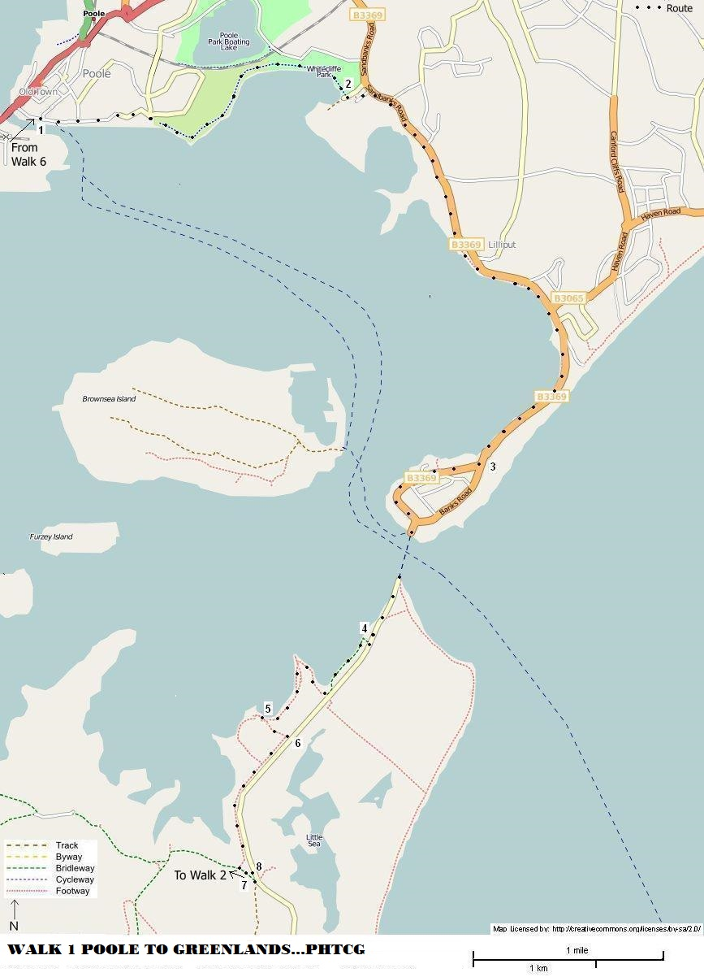
Updated 14/10/21

